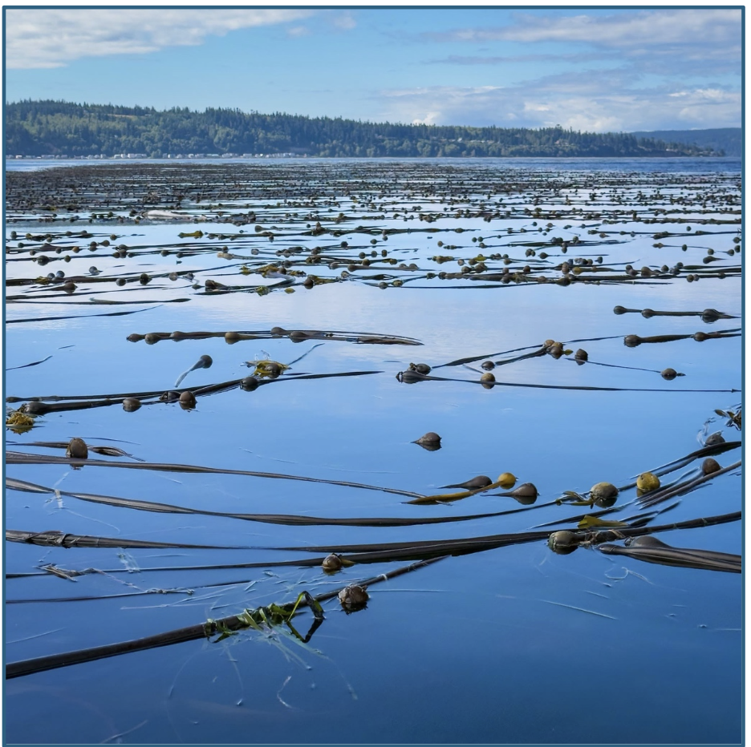

**Photo Courtesy of Dan Hale, Lowell Point MRC Volunteer. Subject, Lowell Point Kelp Forest in August.**

**Understanding How Temperature Shapes Annual Kelp Bed Area**

By Carter Webb, Ahrial Young, & Sydney Golden

**Abstract**

Globally, kelp forests are declining. Research suggests this decline is due to climate-driven shifts in ocean conditions, the Salish Sea is no exception. In this study, our team investigates the impact of environmental parameters, specifically temperature, and their effect on the area of *N. luetkeana* expression on the sea surface in the Salish Sea. Furthermore, we ask, is there variation in the parameters effects as a function of time?

Using data provided by Washington State Marine Resource Committees (MRCs) and the Northwest Straits Commission (NWSC) during nearly a decades long survey (2015-2024), we analyzed 18 different survey sites throughout the Salish Sea. Our particular findings point to the possibility that temperature conditions from previous years could play a role, though there is strong local variation.

**Introduction**

         Long before tidal apps and weather gauges, mariners read the movements of the sea in more tangible ways. Even earlier than tide tables and mechanical instruments, those who traveled the Salish Sea relied on keen observation to navigate safely. Their skills taught them to read waves, winds, and subtle cues in the water. Along the shorelines surrounding modern-day Seattle, the Coast Salish peoples may have used living tools, observing the ebb and flow of canopy-forming Bull Kelp to anticipate tide cycles. Mounting evidence does confirm one thing, however, Bull Kelp, and seaweeds more broadly, have been integral to human life in the Pacific Northwest. From tidal markers to basketry, from food sources to a “kelp highway” that once guided the migration of the first peoples along the Bering coastline and down into the Salish Sea, these underwater forests have shaped human history for millennia.

         Historically, Bull Kelp (*Nereocystis luetkeana*) thrived from the Aleutian Islands to the Central Coast of California. Since time immemorial, those who lived near these underwater forests understood their ecological and cultural importance. In Coast Salish oral tradition, one story tells of a two-headed Bull Kelp that would lead a person to prosperity and respect, if they could only follow its towering stipe down to the seafloor. There, after following 130 feet of stipe, one would be rewarded with their treasure. Beyond its cultural richness, Bull Kelp has long played a structural role in nearshore ecology. Its tissues are rich in nutrients and its forests rich in biodiversity. Moreover, its basic presence reduces wave energy while providing refuge for countless species, and as it ages, deposits its rich nutrients into the water column. This ability to create three-dimensional habitat has earned Bull Kelp the title of ecosystem engineer.

**Theoretical Background**

         The term *kelp* refers to a diverse group of “brown macroalgae,” one of the three major macroalgal groups alongside green (Chlorophyta) and red algae (Rhodophyta) (Mouritsen, 2013). In the tree of life Algae reside within the category of Protists, an eclectic assemblage of misfit eukaryotes that struggle to reflect the typical animals, plants, or fungi. The protists that gave rise to brown algae were among the earliest forms of life on Earth, and over evolutionary time, brown algae became the only lineage in this group to develop complex multicellularity (Seok-Wan Choi, 2024). Such an interesting phenology makes kelp one of the most surprising and fastest growing species on the planet.

         Our main character, Bull Kelp, exhibits a biphasic, heteromorphic life cycle consisting of a large, spore-producing sporophyte phase typically expressive in the summer months creating a visible canopy-forming kelp forest; and a microscopic gametophyte stage which resides on the seafloor and produces gametes, thought to potentially overwinter or survive many years before transitioning back to the sporophyte stage. Both stages are highly sensitive to environmental conditions. While much remains unknown about the microscopic phase, one pattern is clear, rapid environmental change is degrading the success of this life cycle. Bull Kelp has nearly vanished from California’s coastline, replaced by extensive urchin barrens. While closer to home, southern Puget Sound has lost an estimated 80% of its Bull Kelp beds over the past 50 years, along with the biodiversity and ecological services these expansive forests once supported. Today, scientists and volunteers move through the ghostly remnants of these forests to understand what has been lost and what can be done to restore them to their previous glory.

         Recent research has identified the major stressors contributing to kelp decline. Between 2022 and 2024, the Kelp Stressor Rating Workgroup (KSRW) highlighted temperature as one of the most harmful abiotic stressors affecting kelp, particularly during the sporophyte stage, citing major losses in southern Puget Sound (Raymond et al., 2024). Additional studies show that interacting factors, not just stressors in isolation, including nitrogen availability, sedimentation, and hypersaline conditions, can further degrade various stages of the kelp life cycle (Lind & Konar, 2017; Drakard et al., 2025). Furthermore, studies suggests that the effects of these stressors may include temporal lags, with nutrient and temperature conditions from prior years having greater influence on kelp health than conditions within the current growing season (Pfister et al., 2018).

         To track these changing environmental conditions and the health of the kelp forests that still return each summer, Washington State’s Marine Resources Committees (MRCs) have partnered with the Northwest Straits Commission (NWSC) since 2015. Together, county staff, state scientists, and community volunteers collect annual measurements of surface temperature anomalies and maximum kelp bed area from June through September at roughly 30 sites across the region. Since 2015, these surveys have been conducted via kayak using handheld GPS units and various equipment to record temperature. Many of these sites now have 7–10 years of continuous monitoring, and it is from these long-term datasets that our study draws.

         The goal of our study is to examine a subset of MRC–NWSC monitoring sites and assess the relationship between maximum Bull Kelp bed area and temperature variation, seeking evidence of correlations and potential temporal lags that may help explain the ongoing shifts in kelp distribution across the Salish Sea. Our findings will evaluate whether the patterns identified in broader scientific literature also emerge within this smaller, more localized dataset. In doing so, this work aims to inform regional stakeholders about the environmental pressures facing these culturally significant yet rapidly declining kelp forests, and to provide insight into what the future may hold for their resilience and recovery.

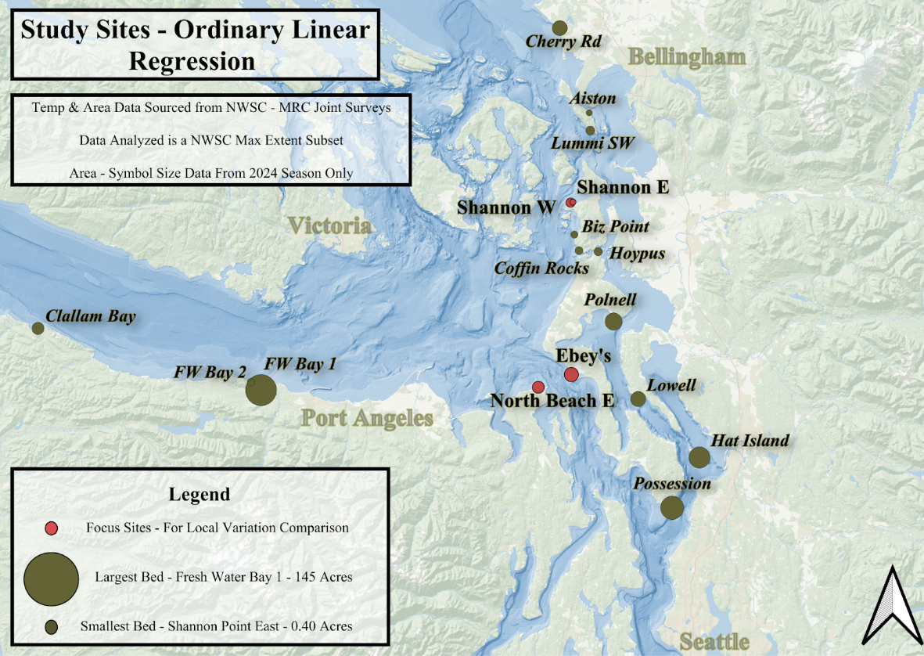

**Figure 1.** Depicts the distribution of all 17 sites included in our study. Size of location marker is proportional to size of area measured in 2024 (acres). The four focus sites for localized comparisons are highlighted in coral.

**Methodology:**

Cleaning:

Source data was provided via Excel workbook, where information was organized into sheets by year. We started with the difficult task of learning how to open and save this data. Since the 17 sites we analyzed have vastly different sizes in acres, we needed to be able to access the information by bed. We did so by first, finding the unique bed names, dropping any duplicates as well as missing data, and associating the information with the correct years.

To start, we made a leaf plot by turning our data into a dictionary object where the bed names are the key and years is the value; this allowed us to view and select beds with the greatest amount of data, greater than or equal to six years. Next, we made each bed into its own dataframe, during which columns were standardized and tidied following best practices and concatenated into one large dataframe of all beds. Finally, we saved each bed as its own csv, in addition to a master all beds csv, this provided a checkpoint where we could now do analysis on shared data between team members. The rest of the cleaning steps were performed on all of the datasets equally.

Due to the collection practices of the MRCs, temperature recordings were found across seven separate columns corresponding to different locations of observation. In order to do analysis, we made one unified column for temperature, by taking averages across columns that had more than one temperature observation per survey. This process went as follows, if there was just one temperature recording, that was used. However, if recordings for both shore edge and water edge were present then we took their average. Otherwise, we averaged the two shore edge and the and two water edge observations. This was done in order to preserve the integrity of the hyper local temperature changes we are hoping to observe. This decision stems from current NWSC - MRC protocols for data analysis.

To stay consistent with these same NWSC - MRC protocols for data analysis, we restricted the data to only the information that had a NWSC code of 1. This designation indicates it was the value the NWSC chose to report for that bed for the year, and always corresponds with the largest observed area in that year. This project is volunteer based, extremely seasonal, and at the whims of weather conditions. As such, data collection can be extremely variable between and within beds, with a range of collection days as well as months. This made it extremely difficult to draw comparisons between years. NWSC is interested in reporting the maximum growth; in using these max extent observations we were able to create continuous data for the majority of beds, analyzing only their largest area value and the temperature that corresponds.

In order to normalize our data and hone in on what parameter is truly driving area change, we created a column to determine the percentage of change in each bed between years. Then, a function was defined to retrieve the temperatures from the previous years, up to four years prior, using the consolidated temperature column we had defined previously. Additionally, we imputed the data using the average temperatures from previous years for the same bed and month of the observations. We know that there is a wide range in acre sizes for the beds (ranging from 0.11 to 169.7 acres). Therefore, we plotted the distribution of bed sizes and found it to be skewed to the right, with many more small beds. However, our efforts to convert to percent acre change did create a data set that did not express such a large skew.

With clean data we were able to progress to analysis. Correlation matrices comparing percent acre change and acres with different temperatures by year were constructed for individual beds and all beds. We did this in order to be able to observe if there were any global trends or if they were all site specific. Multiple Linear Regression (MLR) analysis was then performed and parameters were selected based on the correlation coefficients, corresponding to the normalized percent acre change column, with the greatest magnitude to determine which temperature predictor variable had the most influence. Line plots were created with years on the x axis, best temperature predictors on the left y axis and percent acre change or acres on the right y axis. Lastly, Single Linear Regressions (SLR) were performed on those predictors that were highlighted in the previous step. After modeling, tables were created for multiple and single regressions for percent acre change and acres, comparing different beds, their best predictor variables and whether they were statistically significant based on their p-value.

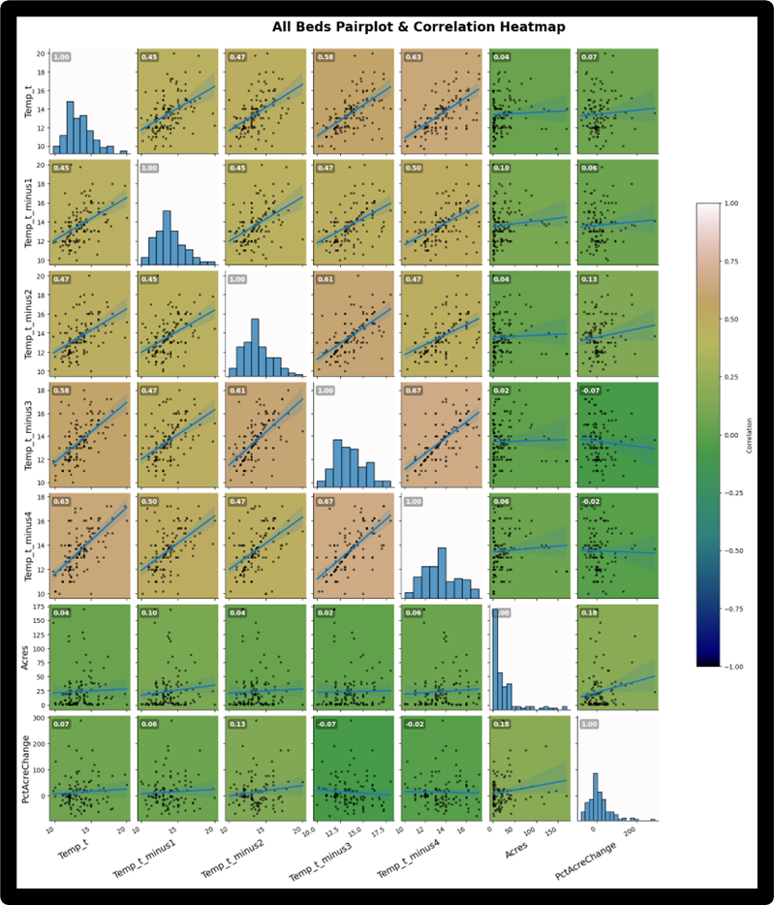**Figure 2.** Depicts a Combination Pairplot and Correlation Heatmap. Correlation Values are Colored Relative t0 the Legend Scale on the Right and are Displayed in the Upper Left Corner of Each Parameter Pair.

**Analysis**

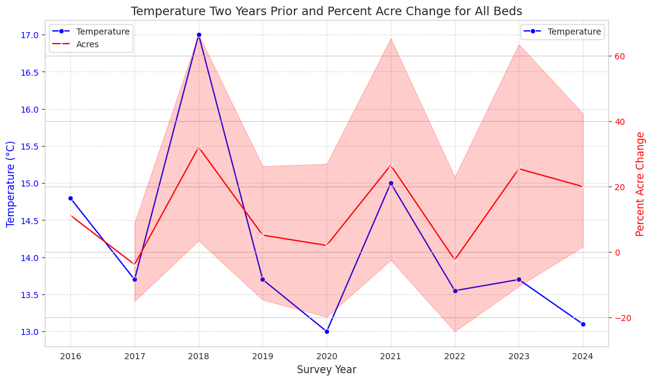Computational Results

**Figure 3:** Depicts a Line Plot Percent Acres Change vs the Best Predictor in Multiple Linear Regression for Percent Acres Change, Temperature Two Years Prior

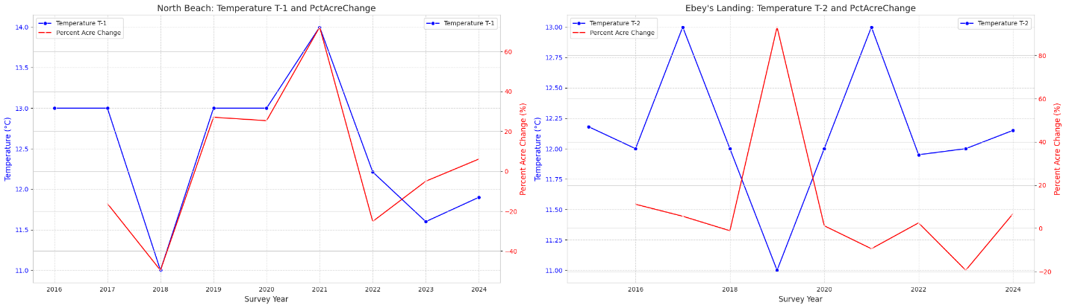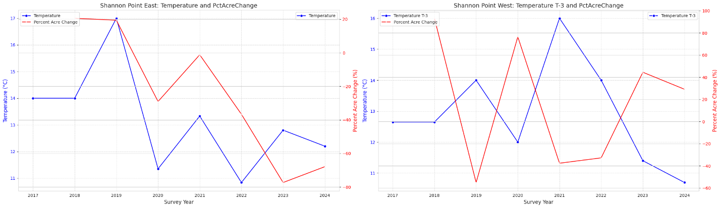**Figure 4:** Depicts Side By Side Comparisons for North Beach and Ebey’s Landing and their Respective Best Predictors from MLR

F**igure 5:** Depicts Side By Side Comparisons for Shannon Point East and West and their Respective Best Predictors from MLR

|  |  |  |  |  |  |  |
| --- | --- | --- | --- | --- | --- | --- |
|  | Bed Name | R-squared | Best Predictor | Coefficient | P-value | Notes |
| 0 | Shannon Point East | 0.807 | Temp_t | 12.599 | 0.413 | No statistically significant predictor at p<0.05. |
| 1 | Shannon Point West | 0.975 | Temp_t_minus3 | -24.600 | 0.144 | No statistically significant predictor at p<0.05. |
| 2 | North Beach | 0.852 | Temp_t_minus1 | 41.389 | 0.106 | No statistically significant predictor at p<0.05. |
| 3 | Ebey's Landing | 0.850 | Temp_t_minus2 | -80.307 | 0.084 | No statistically significant predictor at p<0.05. |
| 4 | All Beds | 0.064 | Temp_t_minus2 | 7.137 | 0.044 |  |

**Table 1:** Shows Results from MLR for Focus Sites and All Beds

Discussion

Our correlation matrix for all beds had no strong correlations, with the greatest magnitude of 0.13 for the temperature two years prior. Based on this, we constructed a line plot to compare the temperature two years prior to percent acre change. We found, graphically, the percent acre change for all beds followed the same increase or decrease patterns as the temperature from two years prior, aligning with our MLR results. SLR and MLR regressions showed relationships between percent acre change and our predictor variables, though their significance varied. Our MLR for percent acre change was determined to be statistically significant with a p value of 0.044, but the small R value of 0.064 showed that our value may not cover much variation in our data. A MLR was also constructed for acres, but did not result in statistical significance, as its p value was large at 0.321. This was expected, as percent acre change is more normalized than simply acres due to variation in this observable spanning from 0.1 acres to 169 acres. With this information, we were able to determine temperature two years prior was the best predictor. However, SLR comparing percent acre change or acres to the temperature two years prior both did not result in statistical significance. Our models show that a combination of temperature predictors from the current year and years prior can explain a small amount of variability in percent acre change of kelp growth.

Highly Localized Variability

During our exploration and analysis stages, we determined that four of our beds with eight or more years of data were exhibiting patterns in pairs. Sites that were close, like Ebey’s Landing and North Beach East, as well as Shannon Point East and West, showed opposing patterns despite being relatively close beds. In order to explore this phenomenon further, we focused on these four sites, comparing line plots and linear regressions of their best predictors.

North Beach East vs. Ebey’s Landing

We had a high correlation coefficient for the percent acre change at North Beach compared to the temperature one year prior at 0.83. This relationship was further explored by constructing a line plot, which displays an almost identical pattern between the temperature one year prior and percent acre change for North Beach. One multiple linear regression comparing percent acre change to the temperature predictors was not statistically significant, but when the multiple linear regression was assessed in terms of acres, we achieved statistical significance at a p value of 0.048 and a high R-squared value of 0.815. A single linear regression for percent acre change against the temperature a year prior also showed statistical significance with a small p value of 0.011. This single linear regression also gave a higher R squared value at 0.690, meaning that 69% of the variation can be explained by our model. Importantly, these findings indicated a positive relationship between temperature the year prior and acres/acre change. On the other hand**,** correlation coefficients for Ebey’s Landing showed -0.69 for percent acre change against the temperature from two years prior. The line plot created for this relationship shows a general pattern of percent acre change decreasing as the temperature increases and vice versa, which is consistent with the negative correlation coefficient we received. Although multiple linear regressions did not indicate statistical significance for the combined impact of our temperature predictors on percent acre change or acres, a single linear regression comparing percent acre change to the temperature two years prior showed statistical significance as our p value = 0.041. Although we found statistical significance in this relationship, our R squared value tells us that the model can only explain 47% of the variability in our data.

It is interesting to find opposing relationships with temperature, let alone temperature of differing years considering Ebey’s and North Beach sit on either side of Admiralty Inlet. We would expect for these two sites to experience relatively similar environmental conditions. However, our data tells a different story.

Shannon Beach East vs. West

Our strongest correlation for Shannon Beach East for percent acre change was the temperature for the current year at 0.63 while Shannon Beach West’s was the temperature three years prior at -0.69. Shannon Beach East’s line plot shows a positive relationship between percent acre change and the temperature of the current year while Shannon Beach West’s line plot displays a negative relationship between percent acre change and the temperature three years prior; echoing similar results from our comparison of Ebey’s and North Beach. Between Shannon Beach East and West, the only model that showed statistical significance was the multiple linear regression comparing acres to all of our temperature predictor variables for Shannon Beach East. Our p value for this model was the smallest out of our whole report at 0.006, and our R squared value was also at its highest at 0.994. Therefore, there is a strong statistical significance in the relationship between acres and a combination of our temperature predictor variables for Shannon Beach East.

**Conclusions**

For our beds assessed, if a bed had a correlation coefficient with a higher magnitude for a certain temperature predictor, a line plot comparing the predictor to percent acre change displayed a strong relationship. Correlation matrix coefficient signs were consistent with the relationships in the line plots between temperature predictors – positive coefficients resulted in percent acre change increasing as the temperature predictor increased and negative coefficients resulted in an inverse relationship. This highlights one of our most notable findings, the reliance of strong local variability between sites and their predictive environmental parameter.

Although we discovered a few statistically significant relationships amongst the best temperature predictor variables and percent acre change/acres, temperature variables provided little insight into these relationships. In certain beds (including our all-beds analysis), multiple linear regressions with all temperature predictor variables being assessed showed statistical significance, implying that a combination of our predictor variables had an impact on percent acre change/acres. For the all-beds multiple linear regression predicting percent acre change, although it resulted in statistical significance it only accounted for about 6% of the variability within our data. The statistically significant relationships that were discovered by singular linear regressions for individual beds had higher R squared values and therefore were representative of a greater variability within our data.

Future analysis should focus on bringing in new data sources like satellite imagery, drone footage, and statewide environmental parameter monitoring to expand this data set. With greater data, we are hopeful the trends will show greater significance. Furthermore, this expansion in data would allow other environmental parameters, such as Nitrogen Concentration, Light Attenuation, and Salinity to be assessed, all of which have been shown in the literature to affect Bull Kelp health in one way or another.

**References**

Choi, S.-W., Graf, L., Choi, J. W., Jo, J., Boo, G. H., Kawai, H., Choi, C. G., Xiao, S., Knoll, A. H., Andersen, R. A., & Yoon, H. S. (2024). Ordovician origin and subsequent diversification of the brown algae. Current Biology, 34(4).

<https://doi.org/10.1016/j.cub.2023.12.069>

Drakard, V. F., Hollarsmith, J. A., & Stekoll, M. S. (2025). Impact of multiple climate stressors on early life stages of North Pacific kelp species. Ecology and Evolution, 15.

<https://doi.org/10.1002/ece3.71661>

Bishop, E. (2014, updated 2023). A kayak-based survey protocol for bull kelp in Puget Sound (Northwest Straits Commission).

<https://nwstraits.org/media/3380/mrc-kelpkayaksurveyprotocol-2023update.pdf>

Lind, A. C., & Konar, B. (2017). Effects of abiotic stressors on kelp early life-history stages. Algae, 32, 223–233.

<https://doi.org/10.4490/algae.2017.32.8.7>

Mora-Soto, A., Schroeder, S., Gendall, L., Wachmann, A., Narayan, G. R., Read, S., Pearsall, I., et al. (2024). Kelp dynamics and environmental drivers in the southern Salish Sea, British Columbia, Canada. Frontiers in Marine Science, 11.

<https://doi.org/10.3389/fmars.2024.1323448>

Mouritsen, O. G. (2013). The science of seaweeds. American Scientist.

https://www.americanscientist.org/article/the-science-of-seaweeds

Pfister, C. A., Berry, H. D., & Mumford, T. (2018). The dynamics of kelp forests in the Northeast Pacific Ocean and the relationship with environmental drivers. Journal of Ecology, 106, 1520–1533.

<https://doi.org/10.1111/1365-2745.12908>

Raymond, W. W., Claar, D. C., Duggins, D. O., Hayford, H., Mumford, T., Pfister, C., Rubin, S., & Magel, C. (2024). Kelp stressor rating in Washington State. Puget Sound Partnership.

<https://www.pugetsoundinstitute.org/wp-content/uploads/2024/06/KelpStressorRanking_FinalReport_4292024.docx.pdf>